Name: Kumaran M
Reg.No: 192525022
Course: Design and Analysis of Algorithm
Course Code: CSA0603

CO4-AT1-Coding Challenge Task

Q21. Activity Selection Problem
A set of activities is given with their start and finish times, and only one activity can be performed at a time.
The goal is to select the maximum number of non-overlapping activities so that overall utilization is
maximized. Activities must be chosen based on an optimal strategy to avoid conflicts. Use a Greedy
approach to determine the best selection.

ANSWERS

Aim:
To select the maximum number of non-overlapping activities using the Greedy Activity Selection Algorithm.
Algorithm:
- Start with the given start and finish times.
- Arrange the activities in ascending order of finish time.
- Select the first activity because it finishes earliest.
- Compare the start time of each remaining activity with the finish time of the last selected activity.
- If start[i] >= lastFinish, select the activity.
- Update lastFinish with the finish time of the selected activity.
- Continue until all activities are checked.
- Print the maximum number of selected activities.

Objectives:
- To understand the Activity Selection Problem using the Greedy approach.
- To select the maximum number of non-overlapping activities.
- To arrange activities based on their finish times.
- To apply the earliest finishing activity strategy.
- To avoid conflicts between selected activities.
- To implement the Greedy algorithm using a suitable programming language.
- To analyze the effectiveness of the Greedy approach in solving the problem.

Program:
n = 4
start = [1, 3, 0, 5]
finish = [2, 4, 6, 7]
activities = list(zip(start, finish))
activities.sort(key=lambda x: x[1])
selected = []
selected.append(activities[0])
last_finish = activities[0][1]
for i in range(1, n):
if activities[i][0] >= last_finish:
selected.append(activities[i])
last_finish = activities[i][1]
print("Selected Activities:")
for activity in selected:
print("Start =", activity[0], "Finish =", activity[1])
print("Max Activities =", len(selected))

Input:
n = 4
start = 1 3 0 5
finish = 2 4 6 7

Output:
Step 1 – Input: Enter the number of activities along with their start and finish times.
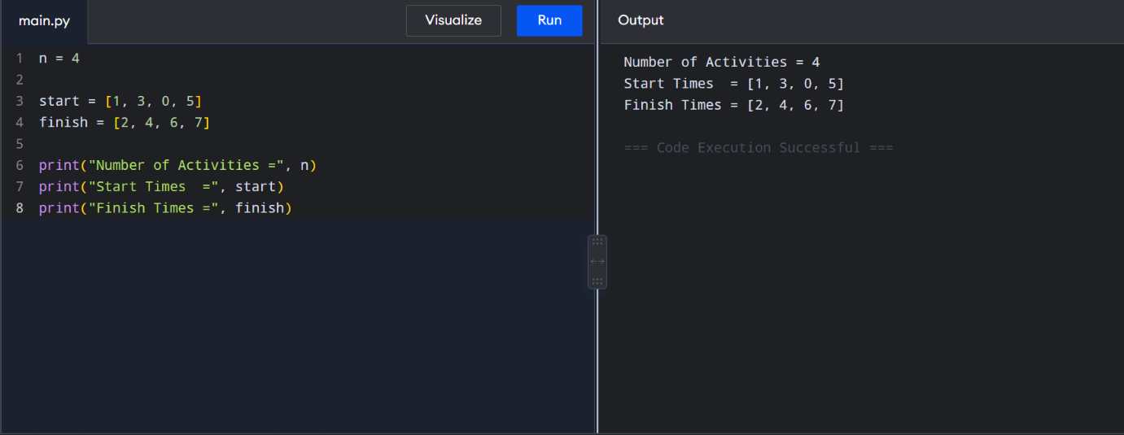

Step 2 – Sorting: Arrange all activities in ascending order based on their finish time.
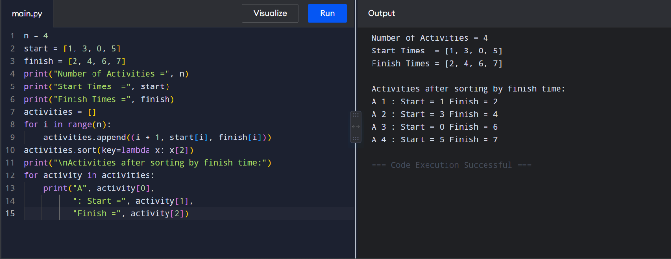

Step 3 – Selection: Select activities that do not overlap with the previously selected activity.
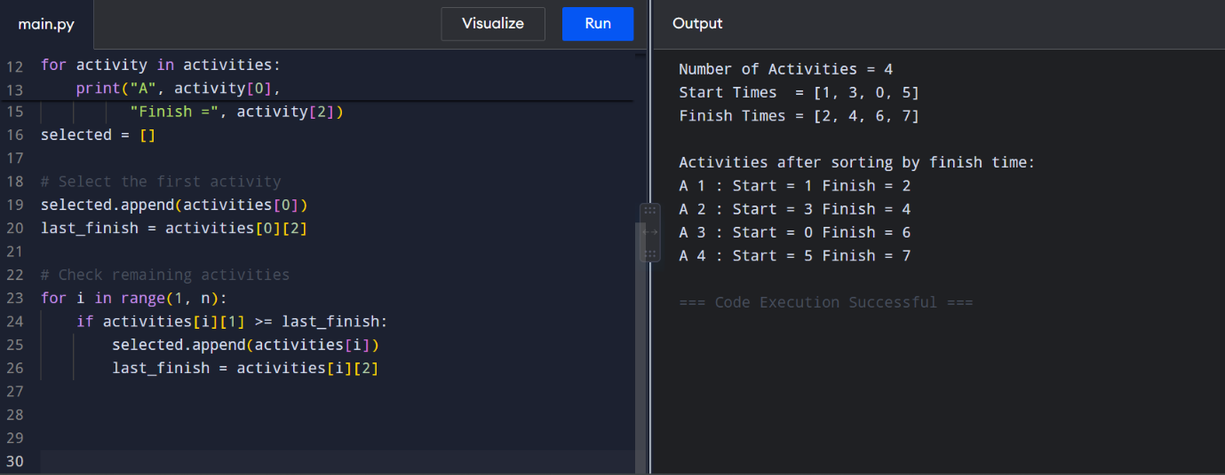

Step 4 – Output: Display the selected activities and the maximum number of activities.
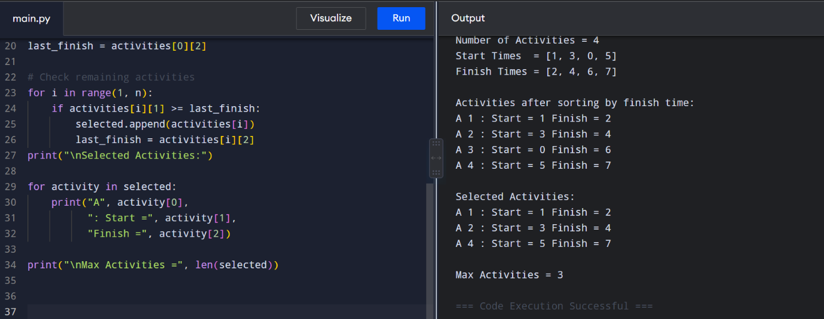

Conclusion:
The Activity Selection Problem was successfully implemented using the Greedy algorithm. The activities were first arranged in ascending order of their finish times, and then non-overlapping activities were selected one by one. This strategy avoids conflicts and maximizes the number of activities performed. For the given input, 3 activities (A1, A2, and A4) were selected. Thus, the Greedy approach provides an efficient and simple solution to the Activity Selection Problem.

